# Weapon Input Test

Date: 27/11/18

This test involves inputting weapon data into the system to determine if there is working connection between the system and database.

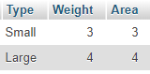

Figure 1. Weapon Input Table

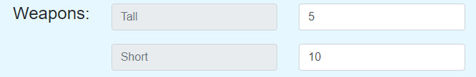

Figure 2. Test 1 - 5 Tall Weapons and 10 Small Weapons

For Test 1, 5 large weapons and 10 small weapons were selected for cargo.

Expected Results:

* Area of Large Weapons: 20
* Weight of Large Weapons: 20
* Area of Small Weapons: 30
* Weight of Large Weapons: 30

Actual Results

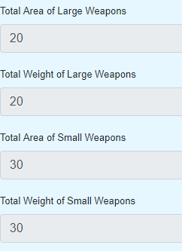

Figure 3. Test 1 Results

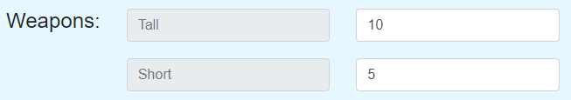

Figure 4. Test 2- 10 Tall Weapons & 5 Small Weapons

For Test 2, 10 large weapons and 5 small weapons were selected for cargo.

Expected Results:

* Area of Large Weapons: 40
* Weight of Large Weapons: 40
* Area of Small Weapons: 15
* Weight of Large Weapons: 15

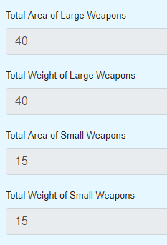

Figure 5. Test 2 Results